Online contribution return user guide
Please visit our website to report your monthly contribution returns.
Your details
- Enter your name, phone number and email address.
- Select the Pension Fund you are in.
- Select your employer’s name from the drop down box or singularly click into the box to enable the search bar.
- Select which financial year from the drop down menu.
- The contribution rate will auto-populate (if you have any queries over this value then please contact us)
- Are you an i-Connect user?
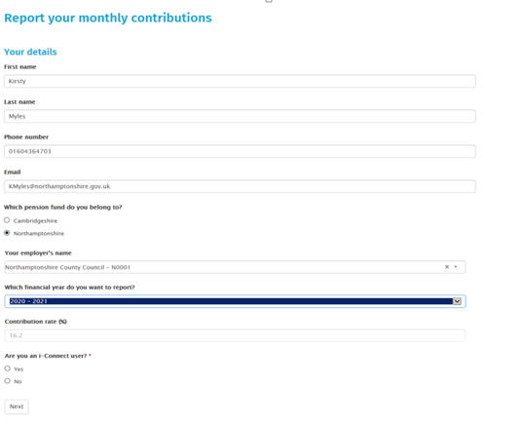
Click ‘Next’.

Submission details – below is an example of the blank form.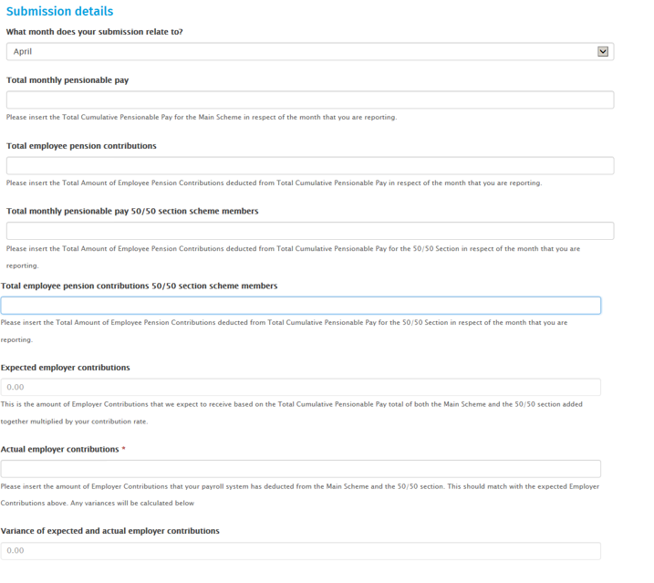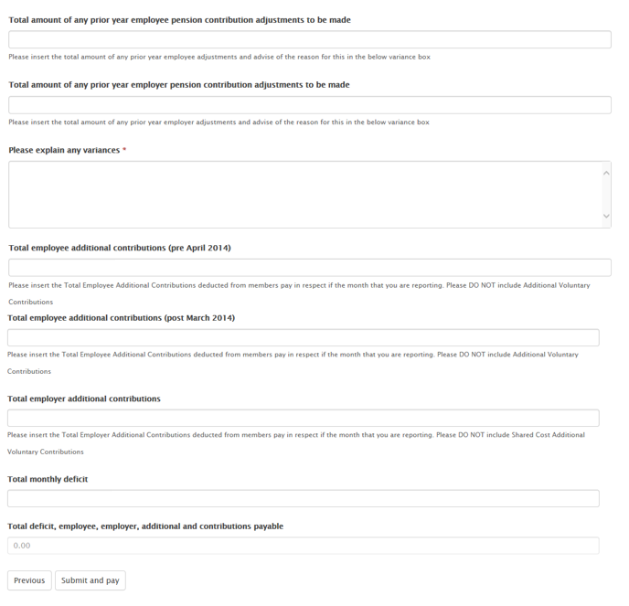
Submission details
In the boxes enter the following information, please note where values are not applicable enter a 0 -
- Please enter the month your submission relates to.
- Total monthly pensionable pay- insert the total gross pay for all the members of your employer who are part of the main scheme.
- Total employee pension contributions - insert the total pension contributions of all the members of your employer who are part of the main scheme.
- Total monthly pensionable pay 50/50 section scheme members - insert the total gross pay for all the members of your employer who are part of the 50/50 scheme.
- Total employee pension contributions 50/50 section scheme members - insert the total pension contributions of all the members of your employer who are part of the 50/50 scheme.

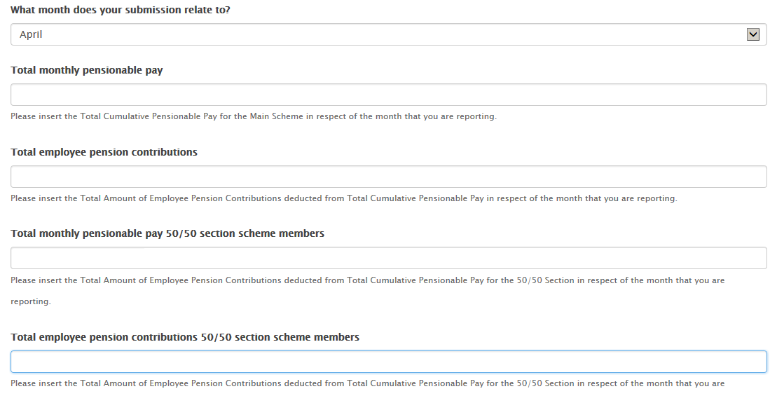

The expected employer contributions will be calculated automatically

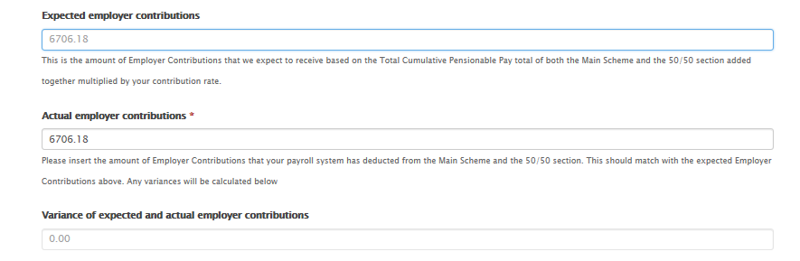
- Actual employer contributions that have been deducted from payroll – insert the total Employer contributions payable across both main and 50/50 scheme members, this figure should be your pensionable pay x employer rate. This is also shown as the above expected total, however when entering your actual deductions there is variance between what is expected and the actual please advise us of the reason for the variance in the box titled “Please explain any variances”

- Prior year adjustments for employee or employer contributions to be made – insert any adjustments that need to be made in regards to the prior year and explain in the variance box why these adjustments are being made.

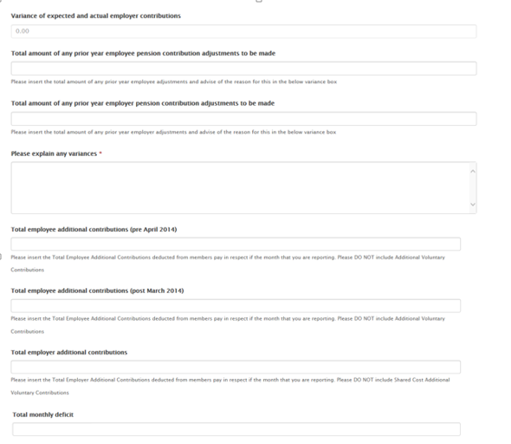
- Please explain any variances – as above commentary if there’s anything you need to tell us it can be completed here.
- Total employee additional contributions (pre April 2014) - insert the total employee additional contributions for member deducted from members pay in respect if the month that you are reporting. Please don’t include Additional Voluntary Contributions
- Enter any employee additional contributions (post March 2014)
- Enter any employer additional contributions
- Enter your monthly deficit amount if applicable.

The fields will then total automatically
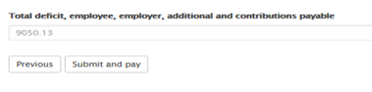
If you’re happy to continue, press ‘Submit and pay’.

Payment section
The details are listed on this page –
- Total to pay
- Reference number to use when making the payment
- Bank details to send the payment to