Online pension account guide
for pensioner members
Version: | 7
Created/amended by: | S Grimshaw
Date: | October 2023

Contents
Section 1 - Sign up 3
1.1 How do I sign up to see my pension account online? 3
1.1.1 Your email address matches the one we have for you 3
1.1.2 Your email address doesn’t match the one we have for you 4
1.2 Does the emailed registration link or posted activation key have an expiry time? 4
1.3 What do I do if the emailed registration link or posted activation key has expired? 4
Section 2 - Registration 4
2.1 I’ve received an activation key; how do I complete my registration? 4
2.1.1 Username 5
2.1.2 Email address 5
2.1.3 Password 5
2.1.4 Security Questions and Responses 6
2.2 I’ve received a registration link how do I complete my registration? 6
Section 3 - Login Procedure 6
3.1 Consent 6
3.2 I’ve registered, how do I login? 7
3.3 I have more than one job, how do I see each job separately? 8
Section 4 - Your dashboard 8
4.1 Your request 9
4.2 Your details 10
4.3 Pension benefits – benefit projectors 11
4.3.1 Death on pension 11
4.4 Employment Details – Financial Details 11
4.5 Death Grant Nomination Details 12
4.6 Documents 13
4.6.1 Scheme documents 13
4.6.2 My documents 13
4.6.3 Uploading documents 13
4.7 Contact Us 15
4.8 News 16
Section 5 - Settings & configurations - password maintenance and security options 16
5.1 How do I change my password? 16
5.2 How do I change my security/lifestyle responses? 17
5.3 How do I update my email address? 18
5.4 What should I do if I forget my password? 19
5.5 What should I do if I forget my username? 20
5.6 What should I do if I forget my security responses? 20
5.7 What should I do if my login is disabled? 20
5.8 Delete Online Pension Account 21

Section 1 - Sign up

1.1 How do I sign up to see my pension account online?
To see your pension account online you need to press ctrl and click this register hyperlink.

This takes you to the ‘Sign up’ page.
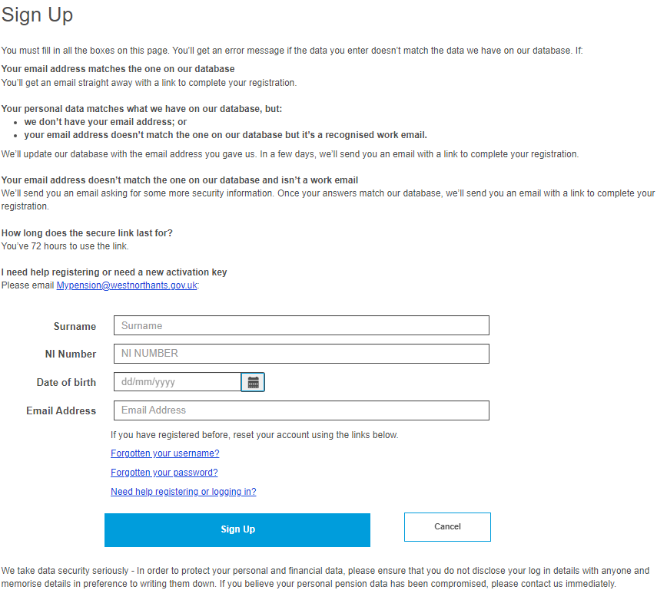

All boxes on the ‘Sign up’ page must be filled in before clicking the ‘Sign up’ button.

Please re-check that your information is right and update where needed.

If you’re still unsuccessful, please send a secure email to MyPension@westnorthants.gov.uk with the information you’re trying to enter. It may be that the information you’re entering doesn’t match the information we have for you.

If the information you’ve entered is the same as the information we have for you, you’ll see a message telling you that your application has been successful.

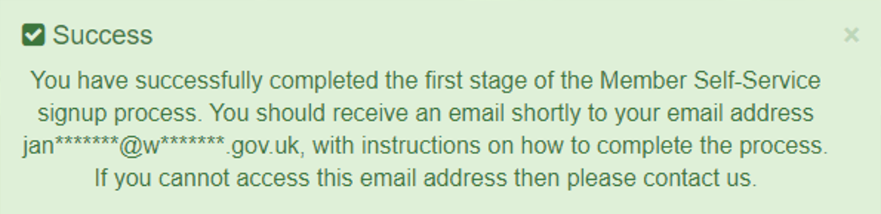

1.1.1 Your email address matches the one we have for you
If the email address you entered is the same as the email address we have for you, we’ll send you a registration link straight away. If we don’t already have an email address for you, we’ll email you a registration link within 24 hours Monday to Friday (excluding bank holidays).
If you click on the registration link, you’ll be taken to the Pension Account registration page. This link is valid for 72 hours. If you’re unable to register during this time, please get in touch with us at MyPension@westnorthants.gov.uk and we’ll send you another link. You won’t need an activation code to register.

Here’s an example of the registration e-mail:

1.1.2 Your email address doesn’t match the one we have for you
If the email address you entered is different to the email address we have for you, a registration link won’t be sent, and we’ll email the address we have for you asking you to give us a call to update your details.

If you’d rather we post you an activation code to your home address, please send us a ‘secure’ email with your national insurance number, date of birth, full name and address to MyPension@westnorthants.gov.uk. A posted activation code is valid for 30 days.

1.2 Does the emailed registration link or posted activation key have an expiry time?
- An emailed registration link expires after 72 hours.
- The posted activation key expires after 30 days after or following successful registration.

1.3 What do I do if the emailed registration link or posted activation key has expired?
You can ask us for a new link (see section 1.1) or email us at MyPension@westnorthants.gov.uk

Section 2 - Registration

2.1 I’ve received an activation key; how do I complete my registration?
You can find your activation code in a letter or email we sent to you. You then need to ctrl and click on this active your account link to get to the ‘Activate your Account’ page:

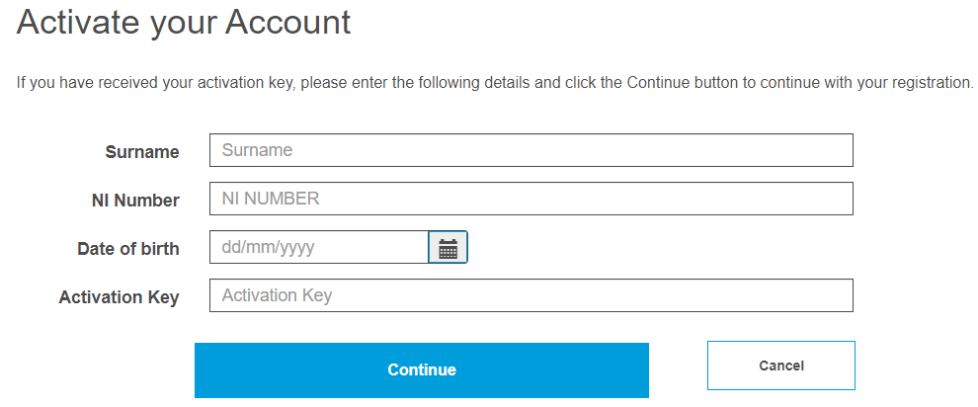

All boxes on the ‘Activate your Account’ page must be filled in before clicking the ‘Continue’ button. If a box is left blank, you’ll see an error message telling you what information is still needed. The activation key is case sensitive, so please enter it as shown on your letter or email. The activation key will expire after 30 days.
Once your account is activated, we’ll ask you to create your username, password and security questions.

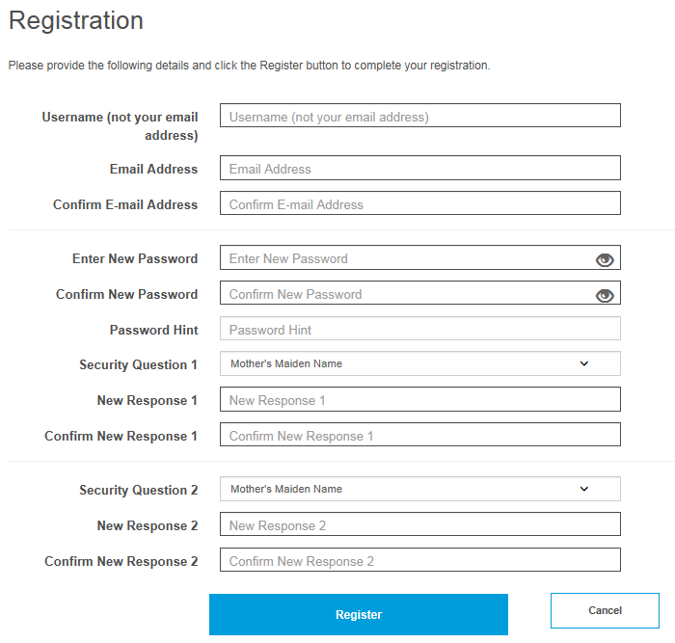

2.1.1 Username
- It must start with a letter, which can be upper or lower case.
- Apart from the first character it can have any alphanumeric characters.
- It mustn’t have spaces.
- It must be between 6 and 30 characters.

2.1.2 Email address
You must enter a valid email address. If it’s different to the address we have for you or if we don’t already have an email for you, we’ll update it once you’ve registered.

2.1.3 Password
- must be at least 8 characters;
- must include at least one number, one lower case, one upper case and one special character;
- are case sensitive;
- must be different from lifestyle/security question responses;
- mustn’t have spaces.

We recommended that you give a password hint to jog your memory.

2.1.4 Security Questions and Responses
You must choose two security questions from the drop-down lists and give responses. The responses mustn’t be the same and must be different from passwords. Responses are case sensitive and must be re-entered exactly the same to log in. Once all boxes have been filled in, please click on the ‘Register’ button.

Registration must be completed within 30 minutes or the session will timeout and you’ll have to start again. After you’ve registered, you’ll see the following:

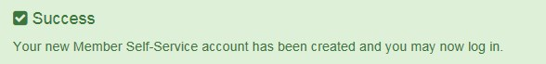

If your registration was unsuccessful it may be that you’ve already registered previously. If that’s the case, you need to enter your details on the login page.

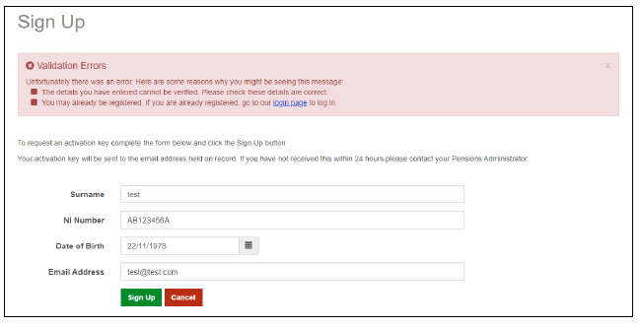

2.2 I’ve received a registration link how do I complete my registration?
This link is valid for 72 hours. Please click on the link in the email and you’ll be taken directly to the registration page. The details of how to complete your registration are above in section 2.1 but you don’t need an activation code.

Section 3 - Login Procedure

3.1 Consent
So we can look after your pension, we need to collect and process certain information from you. When you first log in, you’ll be asked if you’re happy for us to do this. You’ll need to tick the consent box and click ‘submit’.
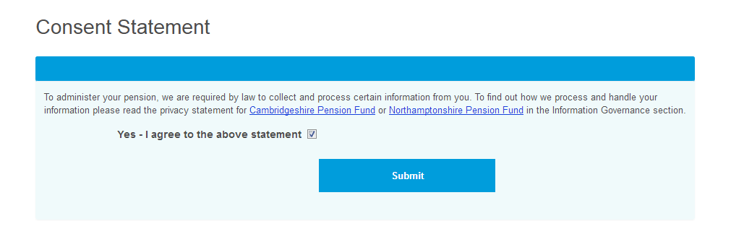
To find out how we process and handle your personal information, please read our privacy statement which can be found in key documents under information governance.

3.2 I’ve registered, how do I login?
Ctrl and click on this login link.
Or on the home page, click on the following ‘Login/Register’ button at the top of the screen.
You’ll then see the Login screen. Enter the username and password that you created during the registration process.
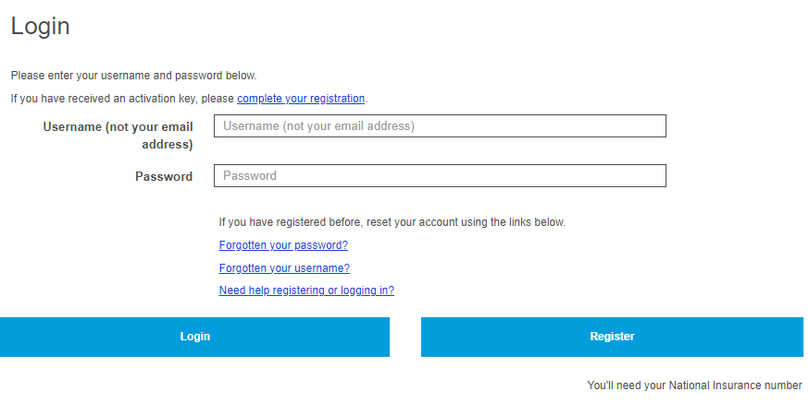

You’ll then be asked one of the security questions that you chose during the registration process. If you’ve forgotten the answer to your security question, click on the ‘forgotten your security response’ link. You’ll then be emailed a security question response reset link.

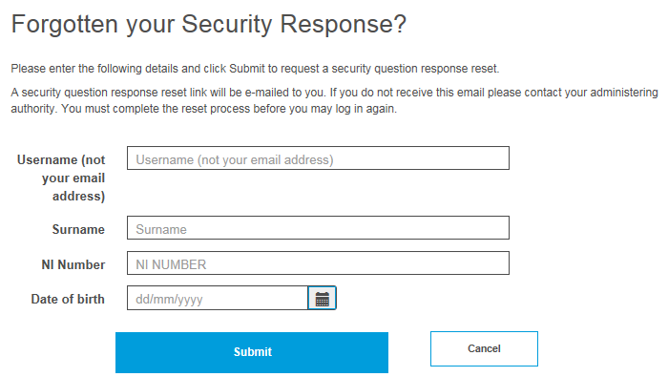

3.3 I have more than one job, how do I see each job separately?
The list includes the employment status, job title, pay reference, and scheme name, to help you choose the right job. You can move between jobs without having to logout and then login again.
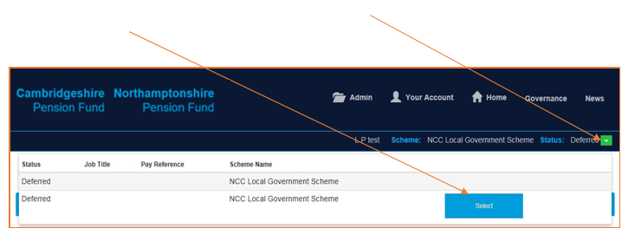
The list includes the employment status, job title, pay reference, and scheme name, to help you choose the right job. You can move between jobs without having to logout and then login again.

Section 4 - Your dashboard
Once you’ve logged in to your account, you can see your Pension Account ‘Dashboard’. By clicking on any of the blue boxes, you’ll be taken to the relevant information.

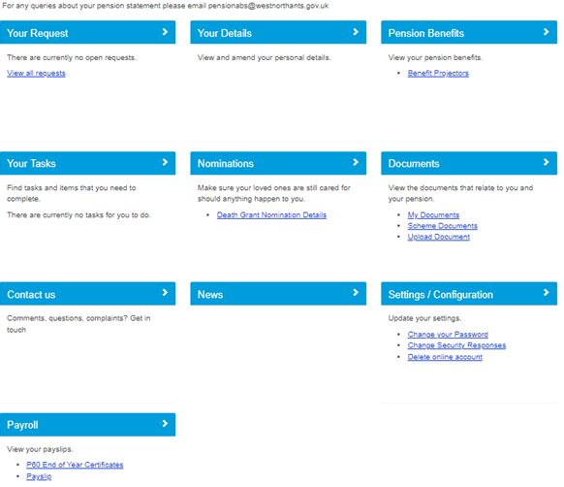

4.1 Your request
This shows you the progress of any requests you’ve made. For example, if you’ve asked your employer for a retirement quote. Having the case number will help you keep track of progress if you’ve made more than one request.

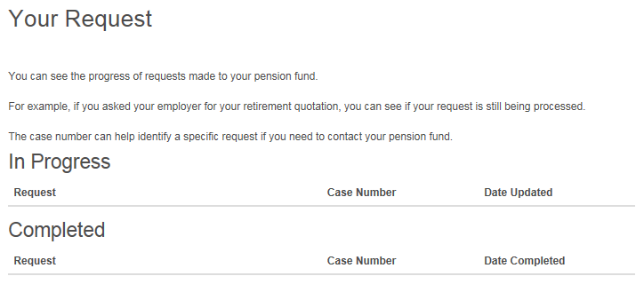

4.2 Your details
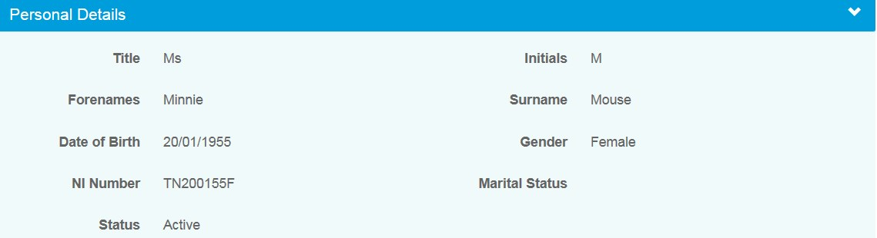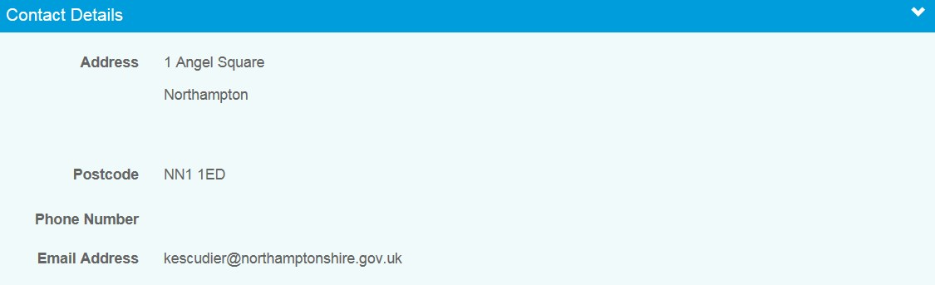

This shows you the personal information that we have for you.

You can make changes to your address, postcode, phone number, e-mail address and privacy preference by clicking the ‘EDIT button.
You can also let us know if you live outside the UK by ticking the overseas member box. Please make sure your postcode is in a valid national standard format in case we need to contact you by post.

Once you’ve made your changes, select ‘SUBMIT’ and the changes will be made in both your Pension Account and our central database.
If you’d like to change any other information then please fill in an update form from the forms and resources page of our website. Please make sure you send any forms that have personal information back to us using ‘secure’ email to protect your personal and financial data.

You can also view your bank details on this page:
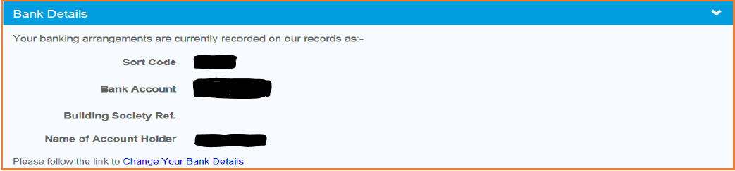

4.3 Pension benefits – benefit projectors
By using the benefit projector, you can work out the value of your pension if you were to die whilst taking it.

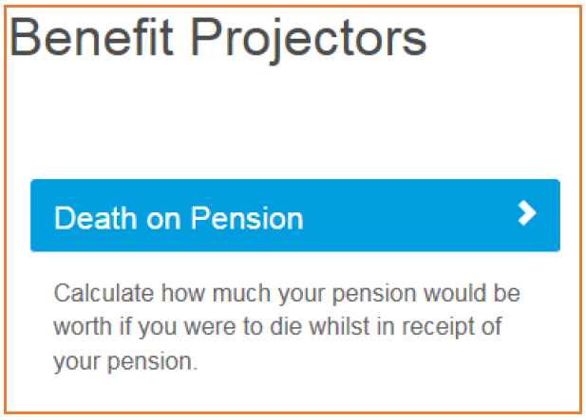

4.3.1 Death on pension
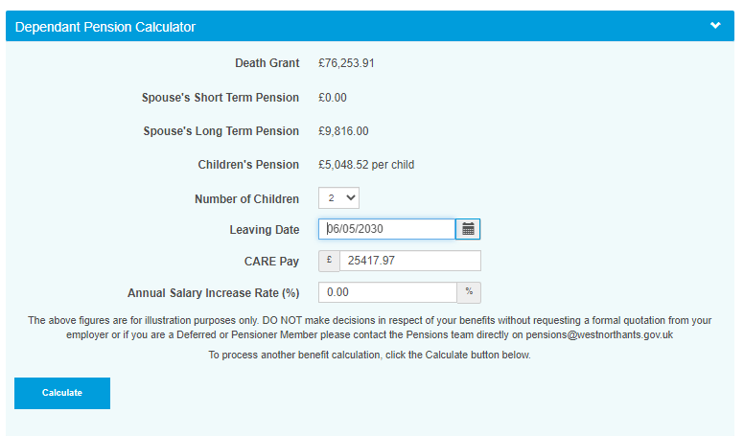
This calculation shows how much your pension would be worth if you were to die whilst taking your pension. You can see your death grant figure plus any beneficiaries’ pension. Using the drop down you can change the number of children, press the ‘calculate’ button to see the revised figures (per child).

The LGPS provides valuable protections for your family if you die whilst taking your pension. Your benefits are partly down to the regulations that were in force when you left pensionable employment, so this is a particularly complex area. You can find out more information on this on our website

4.4 Employment Details – Financial Details
The Financial Details page shows your last annual allowance information. This is for information only as the annual allowance details shown on this page are only relevant if you are currently an active member for this job. The figures are only shown for the tax year(s) before you left your job.

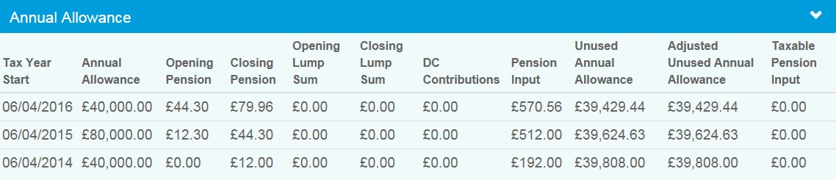

4.5 Death Grant Nomination Details
You can see and change your death grant nomination details held on our database. You can choose to update your beneficiaries. Once you’ve made your changes click on the submit button.

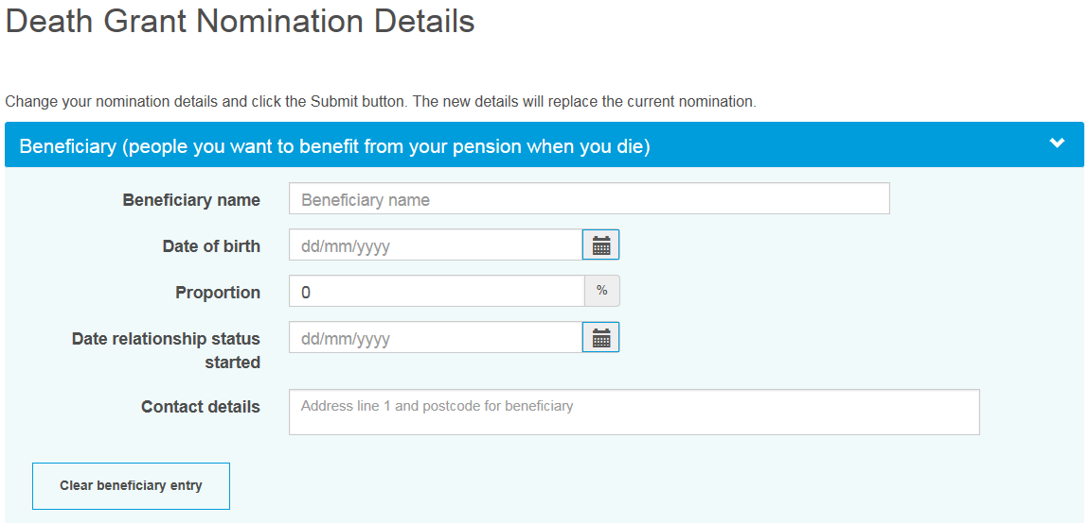
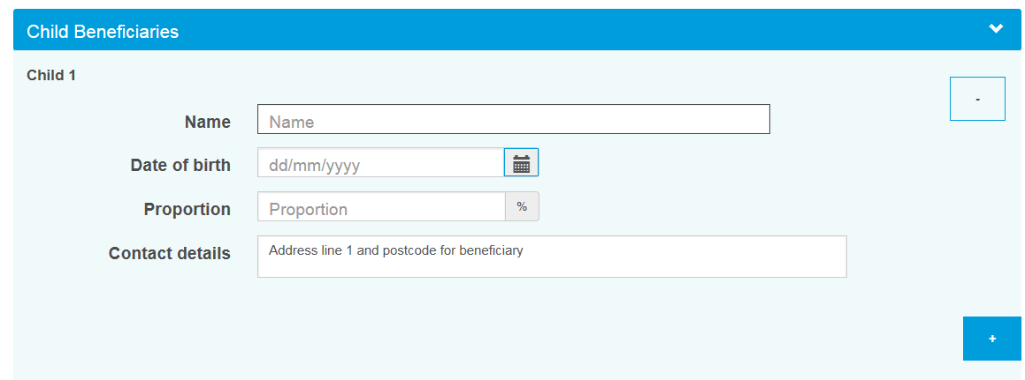
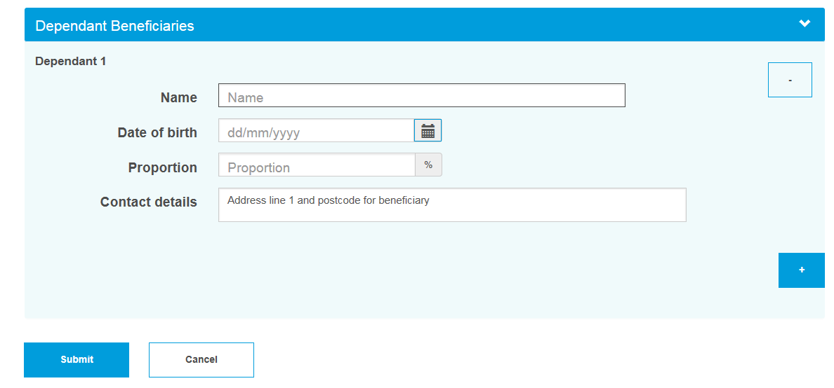

4.6 Documents
4.6.1 Scheme documents – These are general documents about the pension scheme.
4.6.2 My documents – These are personal documents about your pension record.

4.6.3 Uploading documents
If we’ve asked you to upload a document, you can find this service in the Documents section of your Pension Account ‘Dashboard’.
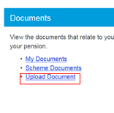
Click on ‘Upload Document’ and:
- Begin by clicking the ‘Select Files to Upload’ button.
- The file selector is displayed.
- Select one or more document files for upload. Only files that are of an approved type are displayed, for example PDF. Multiple files from different folders can be chosen by selecting the first batch of files and then clicking ‘Select Files to Upload’ again to select more.
- After choosing the required files, the webpage will update to display the filename and upload status (including any errors). A remove button will also become available for each chosen file.
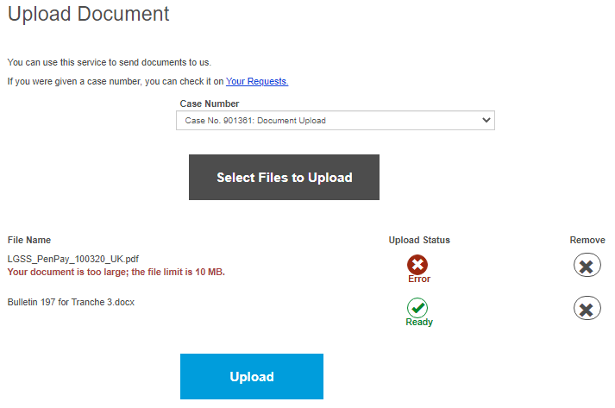

- After reviewing the chosen files, click the ‘Upload’ button.
- Each chosen file is uploaded individually and if successful a ‘Success’ icon will be displayed. If a file fails to upload, an error message describing the reason will be displayed along with an ‘Error’ icon.

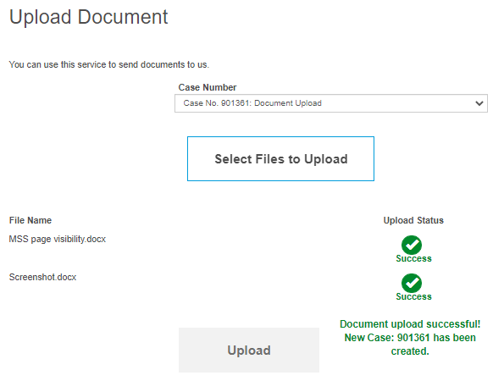

- When all files have been successfully uploaded, a confirmation message is displayed next to the upload button, together with the case number that the documents have been associated with.

A document file upload status will have one of the following statuses:
Status | Status icon | Description
Ready |  | Selected file is ready to be upload. The upload process will only upload files that are in the ready state. If no file is in the ready state, the upload button will be disabled.
Error |  | Selected file failed to pass validation. Please see associated error message for information. These files will not be uploaded. If the error is unexpected, you should email MyPension@westnorthants.gov.uk .
Working |  | Arrows should spin and indicate that the file is currently uploading to Altair. You shouldn’t leave the page until this status changes.
Success |  | Selected file has successfully uploaded.

4.7 Contact Us
If you’d like to contact us with Pension Account query, question or complaint, please select the ‘contact us’ option from your dashboard.

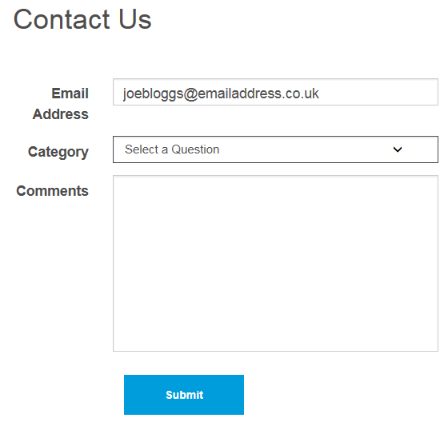
We try to reply to all emails within 24 to 48 hours Monday to Friday (excluding bank holidays) but at busy times this may increase. If your email is about other pension matters, we’ll forward your email to the relevant pensions team who’ll reply to you directly.

4.8 News
This is where you’ll find the latest news from us.

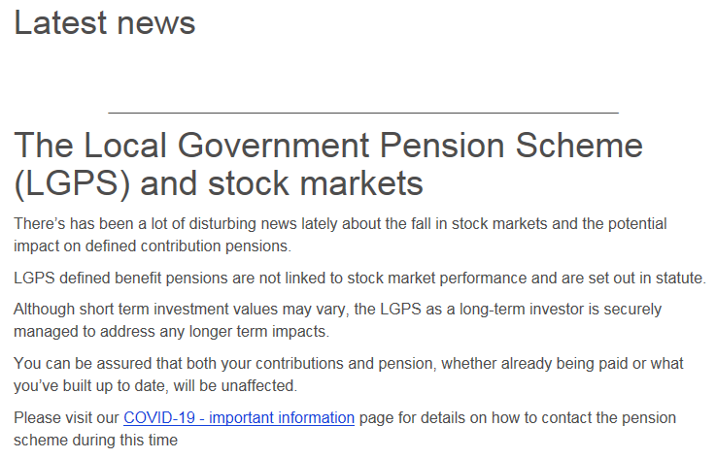

Section 5 - Settings & configurations - password maintenance and security options

5.1 How do I change my password?
You can change your own password by logging into your Pension Account and selecting the ‘Settings / Configuration’ option on your dashboard.

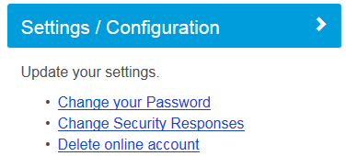

Select ‘Change Your Password’ and you’ll be asked to enter a new password. Please re-enter the new password.

New passwords should:
- be at least 8 characters in length
- must include at least one:
- numeric
- lower case
- upper case
- special character

Passwords are case sensitive and must be different to your security/lifestyle question response.

Providing a password hint is optional. Finally click on the ‘Submit’ button.
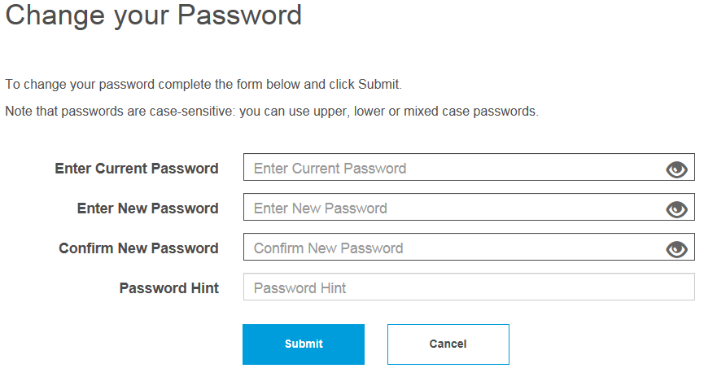
Error messages are shown if any of the fields are not filled in or if the new password and the confirmation of the new password do not match.

Once you’ve successfully changed your password, you’ll receive a confirmation that ‘Your password has successfully been changed’.

5.2 How do I change my security/lifestyle responses?
You can change your own security response by logging into your Pension Account and selecting ‘Settings/Configuration’ option on your dashboard and then select ‘Change Security Responses’.
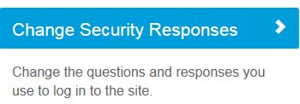

Enter your current password. If you enter an incorrect password, you’ll see error message. If you enter an incorrect password more than 3 times your Pension Account may become disabled, and you’ll need to contact the system administrator using e-mail address MyPension@westnorthants.gov.uk The system administrator will reset this for you and give you a password reset link.

Entries in the ‘New Response’ and ‘Confirm Response’ fields must match exactly. If they don’t, you’ll see an error message once you submit the changes. You must also make sure your security question responses aren’t the same as your password and both security question responses are different.
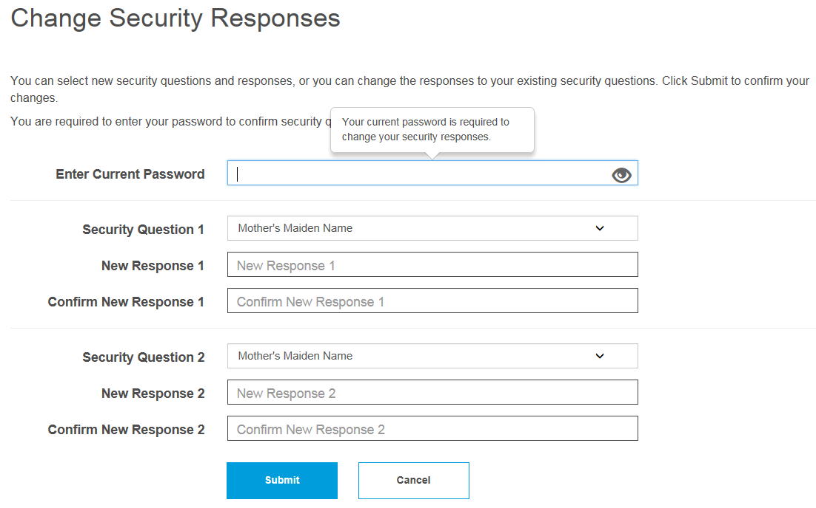
Once you’ve successfully changed your security responses, you’ll see a message on the screen that ‘Your security questions and responses have been successfully changed’.

5.3 How do I update my email address?
You can change your e-mail address by logging into your Pension Account and selecting ‘Your Details’ from the dashboard.
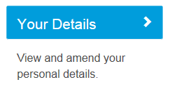
You’ll see a screen showing your contact details including your email address.

Change your email address and then click the submit button.

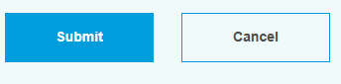

You’ll then see a message that ‘Your E-Mail address has been updated successfully’.

5.4 What should I do if I forget my password?
If you forget your password, you can use the ‘Forgotten your password?’ link.
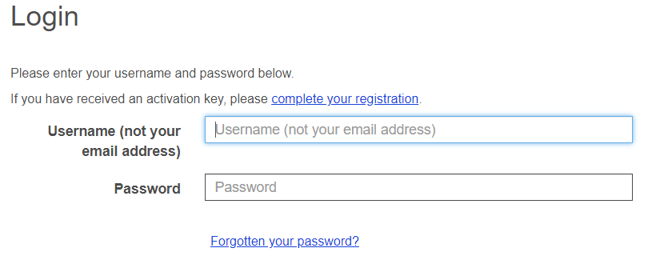
Clicking on this link shows the ‘Forgotten your Password?’ page.

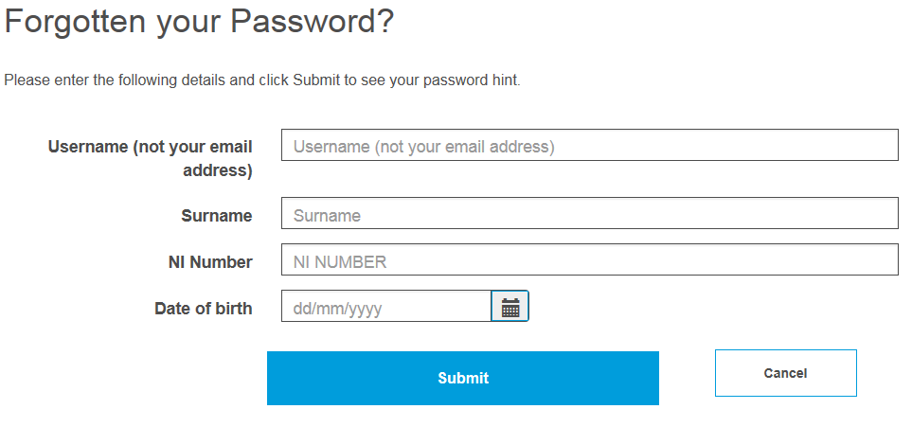

You’ll be prompted to enter your username, surname, NI number and date of birth.

If you gave us a password hint when you first registered, this screen prompts you to remember your password.

If the password hint doesn’t help, you can click the ‘Request Password Reset’ button, from the login page. You will get confirmation that your password reset has been successful. If your contact details include an e-mail address, the password reset link will be emailed to this address, otherwise you’ll need to contact the system administrator (MyPension@westnorthants.gov.uk) and give them your e-mail address.

A secure password reset hyperlink will be sent to the email address recorded on our database. This link is only valid for 24 hours and it is for a single use only. By clicking on the secure link you’ll be taken to a webpage where you can reset your password.

New passwords should:
- be at least 8 characters in length
- must include at least one:
- numeric
- lower case
- upper case
- special character
Passwords are case sensitive and must be different to your security/lifestyle question response.

You’ll then be told that your password has been successfully updated.

5.5 What should I do if I forget my username?
If you forget your username you can use the ‘Forgotten your username?’ link.

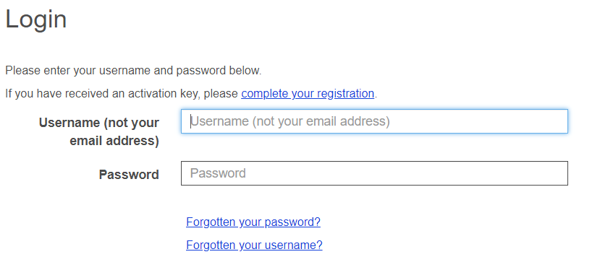
You’ll be asked to enter your surname, NI number and date of birth. If the information is correct, we’ll send you and an email with your username to the email address we have for you on our database.

5.6 What should I do if I forget my security responses?
If you forget the answer to one of your security questions, you can click on the ‘Forgotten your response?’ link.

You’ll see this after you’ve entered your username and password:
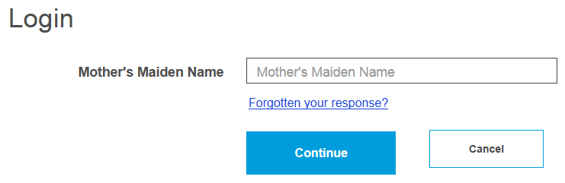

This shows the ‘Forgotten your Security Response?’ page. If you’ve entered the information correctly, we’ll send you an email with a secure hyperlink where you can reset your security questions and answers.

5.7 What should I do if my login is disabled?
If you enter a wrong password or security response three times after another, your account will be disabled, and you’ll see a message saying that ‘Access has been disabled’.

To get back in, you’ll need to enter your:
- Username
- Surname
- NI Reference
- Date of Birth

We’ll then send you an email with a secure password reset link.

If we don’t have an email address for you, please get in touch at MyPension@westnorthants.gov.uk

5.8 Delete Online Pension Account
If you’d like to delete access to your online pension account, please select ‘Settings/Configurations’ from your dashboard.

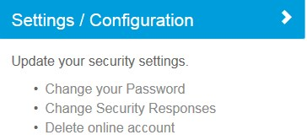

By ticking the ‘Delete online account’ box, you’ll no longer be able to see your pension record, Annual Benefit Statements (ABS), and other pension communications online. You’ll also need to let us know at pensions@westnorthants.gov.uk that you no longer want to see your ABS online and that you’d like future communications to be posted to you.
